October 2026 A&N Academic Montessori School Ltd.
SUN | MONDAY | TUESDAY | WEDNESDAY | THURSDAY | FRIDAY | SAT
 |  |  |  | 1 | 2 | 3
4 | 5 | 6 | 7 | 8 | 9  Show and Tell | 10
11 | 12  Thanksgiving Centre Closed | 13 | 14 | 15 | 16  Show and Tell | 17
18 | 19 | 20 | 21 | 22 | 23  Show and Tell | 24
25 | 26 | 27 | 28 | 29 | 30  Halloween Party | 31

Dear Parents, Guardians and Children:

October 12, 2026, No Daycare- Centre Closed

Show and Tell-Each week your child can bring in an item to talk and share with the class, please try not to bring toys instead bring seasonal items.

Community events

New West Farmers Market
October 1, 2026
3:00 pm
7:00 pm
Tipperary Park

It's never been more important to shop local and the New West Farmers Market has you covered! Everything sold at the New West Farmers Market is either made, foraged, or grown right here in British Columbia, so take the guesswork out of your weekly shop, bring your friends and support the New West economy every Thursday from March 26th - October 29th in Tipperary Park. Shopping for deals? Sign up for a $10 Annual Membership and gain access to exclusive vendor discounts on the first market of every month! Don’t forget to bring your stamp card and after 5 visits be entered into a draw to WIN $50 of Market Money, which can be used at any NWFM vendor. Featuring 45+ vendors, including farm-fresh produce, plants, quality crafts from local artists and artisans, gourmet prepared foods, food trucks, community information, live entertainment, and more! Bring your appetite, your reusable shopping bag, and your family to the market this Thursday!


Details
Date:
Thursday, October 1, 2026
Time:
3:00 pm
7:00 pm
Organizer:
New West Farmers Market

Location
Tipperary Park

2026 All Hallows’ Eve Craft Market
October 3, 2026
October 4, 2026
11:00 am
4:00 pm
318 Keary St. New Westminster
Shop 2 levels of Sapperton Hall filled with over 60 Halloween loving Vendors offering tons of original, spooky, witchy, gothic, mysterious, strange and unusual wares!!

OCT 3rd & 4th 2026

Saturday 11 AM – 5 PM
Sunday 11 AM – 4 PM

Admission: $5 at the door
12 & Under FREE!
Partial Proceeds go to Royal Columbian Hospital

Awesome Free Raffle!
Balloon Twister on Sunday!

Near Sapperton Skytrain Station – TAKE TRANSIT

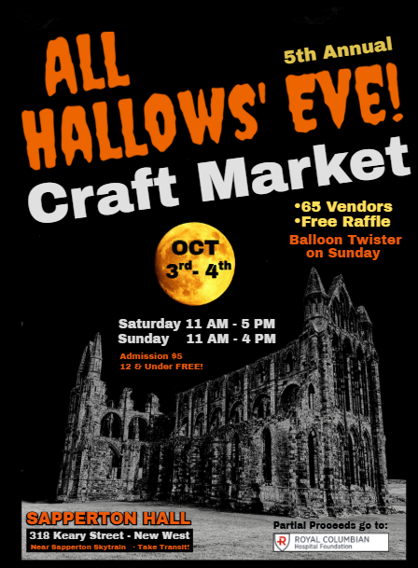

Details
Date:
Saturday, October 3, 2026
Sunday, October 4, 2026
Time:
11:00 am
4:00 pm
Organizer:
All Hallows’ Eve
Cost:
Admission: $5 at the door 12 & Under FREE! Partial Proceeds go to Royal Columbian Hospital
Website:
Click for More info

Location
318 Keary St. New Westminster

New Westminster Fire & Rescue Services Open House
October 3, 2026
10:00 am
2:00 pm
1 Sixth Avenue East, New Westminster (Glenbrook Fire Hall)
Enjoy live demonstrations, exciting equipment displays, informative fire and community safety booths, plus delicious food from the New West Firefighters' Charitable BBQ (by donation). Sparky the Fire Dog will be around to say hello!
This year’s theme is Charge into Fire Safety; Safe Charging is a Superpower, reminding us of the importance of using and charging lithium-ion batteries safely to reduce the risk of fires in homes and communities.
Date and time: Saturday, October 3, 10 AM to 2 PM
Location: 1 Sixth Avenue East, New Westminster (Glenbrook Fire Hall)
Admission is free—everyone welcome!

Note: there is no parking at the Fire Hall. We strongly recommend walking, biking, or taking transit to the event. You may also park by the arena in Queens Park.
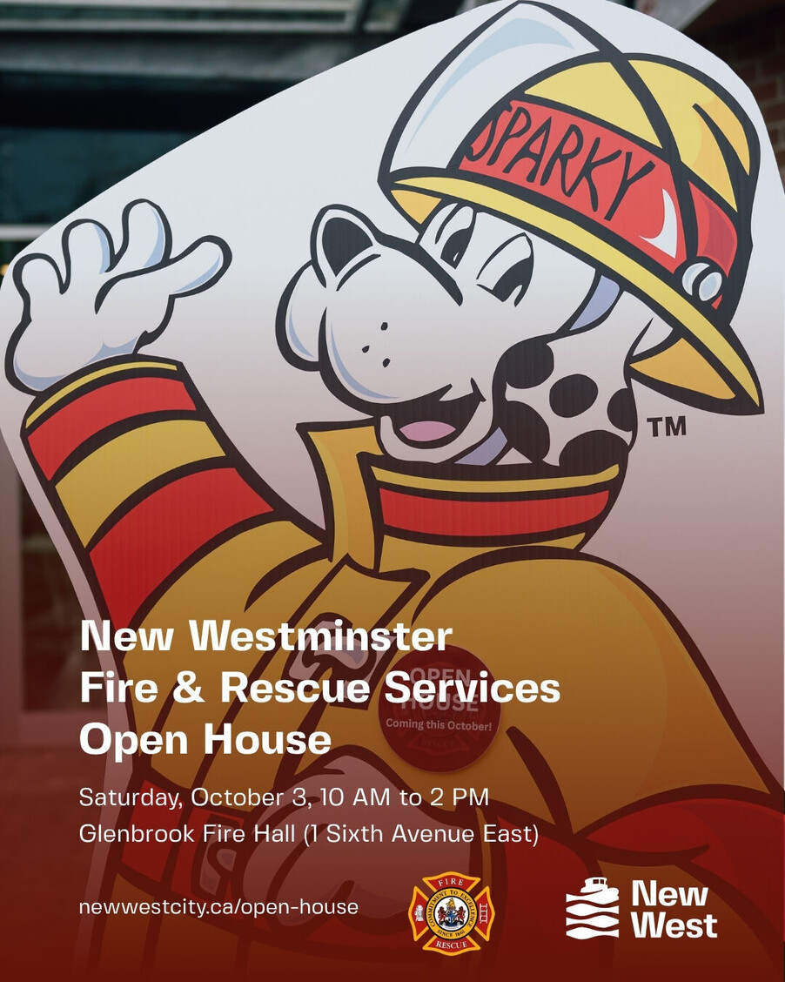

Details
Date:
Saturday, October 3, 2026
Time:
10:00 am
2:00 pm
Organizer:
New Westminster Fire & Rescue Services
Cost:
Admission is free!
Website:
Learn more about New Westminster Fire & Rescue Services

Location
1 Sixth Avenue East, New Westminster (Glenbrook Fire Hall)

City Hall Illumination - Pink, Blue & White - Pregnancy and Infant Loss Awareness Day
October 15, 2026
October 16, 2026
5:00 pm
5:00 am
City Hall, 511 Royal Avenue, New Westminster
City Hall will be illuminated in recognition of Pregnancy and Infant Loss Awareness Day to honour babies gone too soon, remember grieving families, and raise awareness and support throughout the community.

Details
Date:
Thursday, October 15, 2026
Friday, October 16, 2026
Time:
5:00 pm
5:00 am
Organizer:
Kristin Neville Pichoskie
Website:
https://www.facebook.com/share/1WJYKZRye4/

Location
City Hall, 511 Royal Avenue, New Westminster

Cemetery Tour: Halloween Edition
October 30, 2026
October 30, 2026
6:30 pm
8:00 pm
100 Richmond Street
Explore Fraser Cemetery by lantern and uncover the true stories of those who rest there. Along the way, hear tales of mystery, mayhem, and even a case of murder or two drawn from New Westminster's past. From unsolved questions to headline-making crimes, these unique histories reveal a side of the city that is unforgettable.
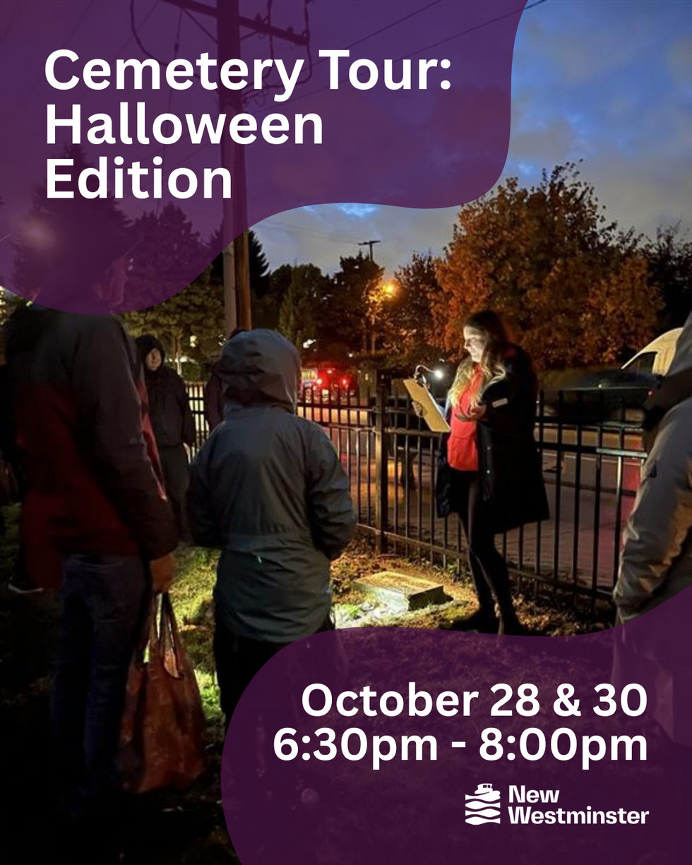

Details
Date:
Friday, October 30, 2026
Friday, October 30, 2026
Time:
6:30 pm
8:00 pm
Organizer:
New Westminster Museum
Cost:
$15.00
Website:
Register Now

Location
100 Richmond Street

