May 2026 A&N Academic Montessori School Ltd.
SUN | MONDAY | TUESDAY | WEDNESDAY | THURSDAY | FRIDAY | SAT
 |  |  |  |  | 1  Show and Tell | 2
3 | 4 | 5 | 6 | 7 | 8  Show and Tell | 9
10 | 11 | 12 | 13 | 14 | 15  Show and Tell | 16
17 | 18  Centre Closed  Victoria Day | 19 | 20 | 21 | 22  Show and Tell | 23
24 | 25 | 26 | 27 | 28 | 29  Show and Tell | 30/31

Dear Parents, Guardians and Children:

New Fees started for April 2026 have come in from the government below you will find the breakdown of our 3 percent increase and the amount of the parent incentive is
0-3 years old $1308- $900 = $408 monthly
3-5 years old $1077-$545= $532 monthly
Jume 2026 A&N Academic Montessori School Ltd.
SUN | MONDAY | TUESDAY | WEDNESDAY | THURSDAY | FRIDAY | SAT
 | 1 | 2 | 3 | 4 | 5  Show and Tell | 6
7 | 8 | 9 | 10 | 11 | 12  Show and Tell | 13
14 | 15 | 16 | 17 | 18 | 19  Show and Tell | 20
21 | 22 | 23 | 24 | 25 | 26  Show and Tell | 27
28 | 29 | 30

No Daycare- Centre Closed May 18

Is the sun harmful to children?
Children have sensitive skin that can easily be damaged by exposure to ultraviolet (UV) radiation (rays) of the sun, even on cloudy or overcast days. Too much sun exposure can cause sunburns, heat stroke/heat exhaustion, skin cancers, cataracts and other eye diseases. During the warm summer months, a child’s sensitive skin can also be burned by touching hot surfaces such as the pavement, outdoor metal slides or car doors.
Research has shown that exposure to UV radiation can also affect the immune system, leading to greater risk of infections and reduced vaccine effectiveness. The sun can also cause premature aging and damage to skin.
Given outdoor play, much of our exposure to UV rays occurs before we are 18 years of age. By the time we are adults, many of us have soaked up more than enough UV rays to cause skin cancer. By protecting children from sunburns and too much sun exposure, you can significantly reduce their risk of developing skin cancer.

How can I protect my child from sun exposure?
Try to keep toddlers and children out of the sun during the peak hours of 10 a.m. to 4 p.m. This is when the sun is the strongest. When you are outside, look for trees and other naturally shady areas for children to play. If possible, use a sun umbrella if you can’t find a shady spot. If you cannot keep your child out of the sun, make sure to protect their skin with “sun smart” clothing and sunscreen.

Sun smart clothing
Encourage your child to be “sun-smart.” Make sure they cover up with loose, appropriate clothes. Closely-woven cotton material offers natural protection from the sun. If you can see through the clothing easily, then UV rays can get through too. A long-sleeved shirt and pants are the best clothes to protect the skin. A wide-brimmed hat without ties, especially one that covers the neck, is recommended. Avoid baseball caps that do not shade the ears or back of the neck. You may consider purchasing lightweight, sun-protective swimsuits and hats that are specially designed for swimming and playing outside.

Sunscreen
Dermatologists strongly recommend a sunscreen with UVA and UVB protection and a Sun Protection Factor (SPF) of 30 or more if you and your child are out in the sun. Use a lip balm with SPF 30 as well. Make sure to use products approved by the Canadian Dermatology Association (look for their name or logo on the label).
For a small number of children, the chemicals in some sunscreens can trigger a skin rash or burn when exposed to the sun. Do a patch test on a small area of skin before applying the product more widely, or use a mineral-based sunscreen that contains zinc or titanium to minimize the risk of a skin reaction.
Apply sunscreen 30 minutes before exposure to the sun so it is absorbed by the skin and less likely to rub or wash off. Apply the sunscreen according to instructions on the package and reapply every couple of hours, after swimming, or following active play time. Swimmers and those who sweat heavily should use a waterproof lotion.
For children wearing bathing suits, make sure that sunscreen is applied up to and under the edges of the suit to protect sensitive areas, such as the upper thighs and chest. Pay particular attention to the ears, back of the neck, tops of feet and the back of the knees. Be careful when applying sunscreen near the eyes. It can be irritating, so avoid the upper and lower eyelids.
Sunscreens, like many other products, have a limited shelf life and become less effective over time. Check the expiry date of old sunscreen containers and replace them if they are out of date.

Do I need to take extra precautions to protect my baby from the sun and heat?
Yes. Babies younger than 12 months of age are especially sensitive to UV radiation and heat. It is safest to keep babies younger than 12 months out of the sun. Try to find or create shade for your baby if you are going to be outside. Use a stroller with a sunshade if possible. If your baby must be in the sun, you can apply sunscreen to small areas of skin that aren’t covered by clothing or a hat. Sunscreen is not recommended for babies less than six months of age as they can rub it in their eyes and mouth. Make sure to use a sunscreen approved by the Canadian Dermatology Association.
Do not let your baby get dehydrated or overheated. Make sure your baby is well hydrated in hot weather by offering breastmilk or something to drink every hour or so. Never leave your child alone in the car.

Should I protect my child’s eyes from the sun?
Yes. The same UV rays that harm your child’s skin can also injure their eyes. Babies and children are particularly at risk. Standards for sunglasses have improved, and most brands are effective at screening or reflecting ultraviolet rays. Look for sunglasses that provide 99 to 100 per cent UVA and UVB protection.
When buying sunglasses, see how well they cover the eyes. Large lenses, glasses that fit well, and a wrap-around design all help protect against damaging UV rays. Have your clear plastic or glass corrective lenses checked for UV protection.

What are other risks?
Skin cancer can develop in any skin type. Be extra careful with children who are fair-skinned and/or who have blond or red hair. They are more likely to burn easily and are most at risk of developing skin cancer later in life.
Most of the sun's damaging UV rays can penetrate light cloud cover and haze, so remember to protect your child even if it is cloudy or does not feel hot. UV rays reflect off many of the surfaces around us. Up to 80 per cent of the sun's UV rays can be reflected off snow. Concrete, sand and water reflect less than 20 per cent. Children always need to be “sun-smart” whether they are skiing, swimming, playing or walking outdoors.

What are other sun safety tips?
- Always protect your child’s skin and try to stay indoors or in the shade during the hottest time of day (10 a.m. to 4 p.m.)
- If you have to go out in the sun without protective clothing, use sunscreen. Do not forget to apply it to ears, nose, and neck
- Sunscreen is intended to enhance protection during periods of sun exposure – not to increase time of sun exposure
- Do not wait for signs of sunburn to get your child out of the sun, Sunburns do not usually show up for 6 to 24 hours
- A tan does not provide enough protection against the sun’s rays. Actually, having a tan means that your skin has been damaged already by UV radiation
- Teach children to be “sun-smart” and to protect themselves against exposure to the sun
- Encourage your child to drink plenty of water
- Indoor tanning beds and/or sun lamps are regulated by provincial law that does not allow children under 18 years old to use them. At any age, these devices damage your skin the same way UV radiation from the sun does

Show and Tell-
Each week your child can bring in an item to talk and share with the class, please try not to bring toys instead bring seasonal items.

Community Events

MARCH 26-MAY 28

Zoom Connections
FREE
FREE exhibit at the Anvil Centre Community Art Gallery!

Tuesday Night Rides
May 12, 2026
May 12, 2026
6:00 pm
8:00 pm
Century House, 620 Eighth Street
An 18 km bike ride for beginner and casual cyclists to təməsew̓txʷ Aquatic & Community Centre, Glenbrook Ravine, Royal Columbian Hospital, and Queen's Park.
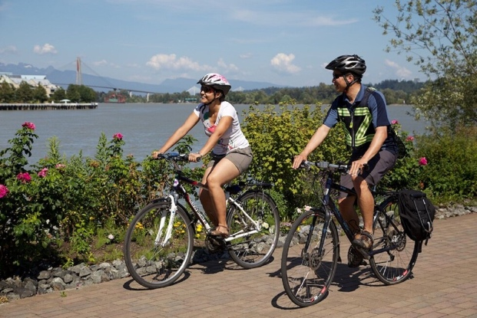

Details
Date:
Tuesday, May 12, 2026
Tuesday, May 12, 2026
Time:
6:00 pm
8:00 pm
Organizer:
HUB - New Westminster
Cost:
Free
Website:
Register Now

Location
Century House, 620 Eighth Street

New West Museum Quest
May 18, 2026
May 24, 2026
12:00 am
11:59 pm
777 Columbia St
New West Museum Quest May 18 - 24 Celebrate International Museum's Week by exploring New Westminster’s museums and galleries in a whole new way with the New West Museum Quest! For one week only, visitors are invited to take part in a city-wide BINGO-style challenge to discover local arts and heritage spaces, collect stamps, and earn chances to win a New West Prize Pack. How It Works Pick up a BINGO card Available at any participating museum or gallery starting May 18. Visit participating locations Each location you visit will stamp your card. Complete a line or the full card Complete one line (horizontal, vertical, or diagonal) to be entered into the prize draw Complete the full card (visit all 9 locations) to receive 10 entries into the draw Submit your completed card Submit you completed card at any participating location to be entered into the prize draw. Participating Locations Visit all 9 locations to complete your BINGO card: Canadian Lacrosse Hall of Fame (777 Columbia St) Community Art Gallery (777 Columbia St) Fraser River Discover Centre (788 Quayside Dr) Irving House (320 Royal Ave) New Media Gallery (777 Columbia St) New Westminster Community Sports Hall of Fame (51 Third Ave) New Westminster Museum & Archives (777 Columbia St) Samson V Maritime Museum (880 Quayside Dr) The Gallery at Queen's Park (Centennial Lodge, Queen's Park)
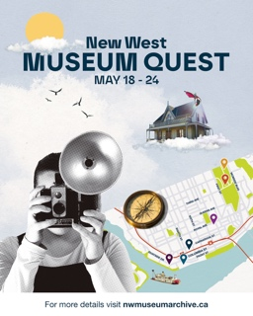

Details
Date:
Monday, May 18, 2026
Sunday, May 24, 2026
Time:
12:00 am
11:59 pm
Organizer:
New Westminster Museum & Archives
Cost:
Free
Website:
Learn More

Location
777 Columbia St

Hyack Multicultural Parade
May 23, 2026
11:00 am
1:00 pm
Uptown New Wesminster
The annual Hyack Parade is BC's largest family-oriented parade with over 100 entries from throughout the region. You won’t want to miss the high-energy, colourful, and entertaining procession of floats, marching bands, community groups, mascots, performance artists, and more that fill the streets of New Westminster. It’s a “can’t miss” event for the entire family! Whether you're a marching band, a small business with a brightly decorated vehicle and costumed staff, or even a community club that knows how to whoop it up in a fun marching formation, we want you to join us!

​Bring out your community spirit, promote your brand or organization, and brighten the smiles of a huge captive audience!


Details
Date:
Saturday, May 23, 2026
Time:
11:00 am
1:00 pm
Organizer:
Hyack Festival Association
Cost:
Free!
Website:
Learn More!

Location
Uptown New Wesminster

Hyack Festival in the Park
May 23, 2026
11:00 am
5:00 pm
Tipperary Park
Join us for a day of fun in the sun with a variety of activities for all ages. Enjoy the variety of international foods in front of City Hall, wander up behind the building for the Kids' Zone and City Works Exhibit, and continue through the park for the incredible variety of 60+ vendors, interactive arts exhibits, and live Multicultural performances from 1-5 pm.

Details
Date:
Saturday, May 23, 2026
Time:
11:00 am
5:00 pm
Organizer:
Hyack Festival Association
Cost:
Free!
Website:
Learn More!

Location
Tipperary Park

New West Craft Indigenous Market
June 6, 2026
June 6, 2026
11:00 am
5:00 pm
810 Quayside Derive
Celebrate the 5th Annual Indigenous Market & Expressions of Reclamation on June 6 from 11am–5pm at the New West Quay boardwalk in front of River Market.

This free community event features over 65 Indigenous artists and makers, live music performances, Indigenous food vendors, a fashion show, interactive art activities, and cultural experiences for all ages. Enjoy performances by George Leach, Kiva MH, IIona, Murray Porter, and Joseph Dandurand, take part in a beading workshop with Marisa Law, and explore community activations including Spirit of the Children Society’s teepee experience.

The event supports Indigenous artists and entrepreneurs while celebrating culture, creativity, and economic reconciliation.

Free to attend.
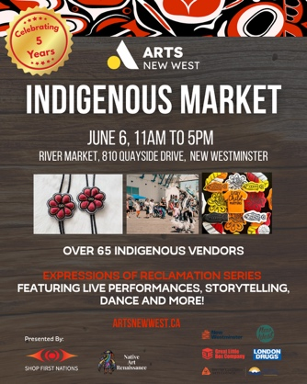

Details
Date:
Saturday, June 6, 2026
Saturday, June 6, 2026
Time:
11:00 am
5:00 pm
Organizer:
Arts New West
Cost:
Free
Website:
https://artsnewwest.ca/new-west-craft-indigenous-market-and-expressions-of-reclamation/

Location
810 Quayside Derive

Clean Up New West
June 13, 2026
June 13, 2026
9:00 am
1:00 pm
315 Queens Ave
Clean Up New West is Westminster House's annual signature event. This is Westminster House's way of giving back to the community that has nurtured our recovery programs for 43 years. On Saturday, June 13, we invite members of our community to join us in cleaning up our community. Celebrate the beauty of New Westminster over a clean-up competition, free lunch, live music, and our hilarious pie-eating contest.

ATTENTION: We do not take large items for our clean up contest. If the item will not fit in a garbage bag, please do not bring it back to our weigh station. This is to ensure that everything we dispose of on site is disposed of properly and in an eco-friendly way.

9:00 am - Registration opens, litter clean up begins

10:30 am - Garbage weigh station opens

11:00 am - Food truck starts serving lunches (food truck is open until 1:00 pm)

12:00 pm - Announcements and prizes

12:15 pm - Pie-eating contest
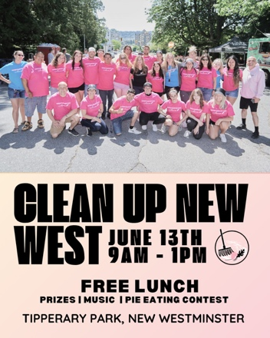

Details
Date:
Saturday, June 13, 2026
Saturday, June 13, 2026
Time:
9:00 am
1:00 pm
Organizer:
Westminster House Society
Cost:
FREE
Website:
Register for FREE Now!

Location
315 Queens Ave

National Indigenous Peoples Day
June 19, 2026
10:00 am
2:00 pm
Moody Park, New Westminster
Join us for a National Indigenous Peoples Day celebration. Gather your friends and family, and bring a blanket or lawn chair, and enjoy a day of music, dance, culture, and community.
Opening remarks & protocol at 9:30am, with the main event starting at 10:00am.
Details about live performances, food options and the artisan market will be posted closer to the event date.
This event is hosted in collaboration with the Spirit of the Children Society, Qayqayt First Nation and the City of New Westminster.
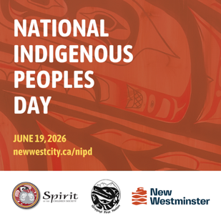

Details
Date:
Friday, June 19, 2026
Time:
10:00 am
2:00 pm
Organizer:
In collaboration with the Spirit of the Children Society, Qayqayt First Nation and the City of New Westminster
Cost:
Free
Website:
Performer and Vendor Bios

Location
Moody Park, New Westminster

Mechanics of Music Fest
June 27, 2026
12:00 pm
6:00 pm
Westminster Pier Park (1 6th Street, New Westminster, BC)
Mechanics of Music fest is a joyful community music festival where students, teachers, local performers, families, and music lovers come together for an unforgettable day at Westminster Pier Park. Presented by Rock the Block Society. This year’s event will also feature a local vendor and sponsor market, and our infamous Instrument Petting Zoo, where you can come out to try different instruments. Music is for everyone!
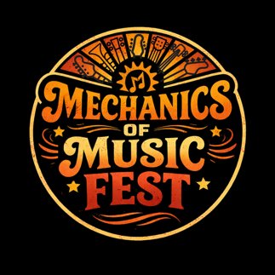

Details
Date:
Saturday, June 27, 2026
Time:
12:00 pm
6:00 pm
Organizer:
Mechanics of Music
Cost:
Free
Website:
Learn More

Location
Westminster Pier Park (1 6th Street, New Westminster, BC)

Century House Association Craft & Bake Sale
June 27, 2026
10:00 am
2:00 pm
Century House
Join us for our Summer Craft & Bake Sale. Shop and browse for handmade items and baked goods from our own Century House craft groups and local artisans. Door prizes and other fun surprises await!
Century House
Saturday, 10:00 am - 2:00 pm
June 27
Free event
Learn more: centuryhouseassociation.com



Details
Date:
Saturday, June 27, 2026
Time:
10:00 am
2:00 pm
Organizer:
City of New Westminster
Cost:
FREE
Website:
Learn more about Century House Association

Location
Century House

