December 2025 A&N Academic Montessori School Ltd.
SUN | MONDAY | TUESDAY | WEDNESDAY | THURSDAY | FRIDAY | SAT
 | 1 | 2 | 3 | 4 | 5  Show and Tell | 6
7 | 8 | 9 | 10 | 11 | 12  Show and Tell | 13
14 | 15 | 16 | 17 | 18 | 19  Potluck  Christmas Concert  12:00-2:00 | 20
21 | 22  CENTRE CLOSED  Winter Break | 23  CENTRE CLOSED  Winter Break | 24  CENTRE CLOSED  Winter Break | 25  CENTRE CLOSED  Winter Break | 26  CENTRE CLOSED  Winter Break | 27
28 | 29  CENTRE CLOSED  Winter Break | 30  CENTRE CLOSED  Winter Break | 31  CENTRE CLOSED  Winter Break

January 2026 A&N Academic Montessori School Ltd.
SUN | MONDAY | TUESDAY | WEDNESDAY | THURSDAY | FRIDAY | SAT
 |  |  |  | 1  CENTRE CLOSED  Winter Break | 2  CENTRE CLOSED  Winter Break | 3
4 | 5  Centre Re Open After Winter Break | 6 | 7 | 8 | 9  Show and Tell | 10
11 | 12 | 13 | 14 | 15 | 16  Show and Tell | 17
18 | 19 | 20 | 21 | 22 | 23  Show and Tell | 24
25 | 26 | 27 | 28 | 29 | 30  Show and Tell | 31

Dear Parents, Guardians and Children:

What a wonderful year we have had in our new location, thank you to all those who helped make our centre a warm and caring environment. Thank you to the A&N team who have been incredible at what they do

Our annual Christmas Concert is coming up- please join us for a short performance and potluck lunch. Daycare will remain open before and after the event. The doors open at 12:00pm, concert will start at 12:30pm. Please sign up for potluck lunch the teachers have a sign-up sheet, we are asking parents to provide peanut/seafood free dishes.

December 22, 2025 – January 2, 2026, No Daycare- Centre Closed- Winter break
We hope you all a Merry Christmas and Happy New Year1
Funds Raised Due for Purdy’s Chocolate Bar Fundraiser have been collected, and the playground will have new toys and equipment in the coming weeks!
Show and Tell-Each week your child can bring in an item to talk and share with the class, please try not to bring toys instead bring seasonal items.

COMMUNITY EVENTS

Downtown's Living Room: Artisan Craft Market
December 1, 2025
5:30 pm
8:00 pm
777 Columbia Street, New Westminster
Come celebrate this holiday season at Anvil Centre’s Downtown Living Room, where Arts New West will be hosting their Artisan Holiday Market! You’ll find various handcrafted holiday gifts and artworks, all while supporting our talented New Westminster artists. A big thank you to Arts New West for this wonderful opportunity. We can’t wait to see you all there! December 1 Vendors Linda Shea: Jewelry Won Kang: Art prints & stickers Artsy Candle: Candles Sara Polanco Ruiz: Crochet Evangeline Lapalme: Art prints & stickers Juliana Silva Studio: Textiles Chantelle Martin: Textiles Downtown's Living Room will run Monday nights (excluding holidays) at 5:30 PM. This is your chance to come hang out, relax, make new friends and enjoy different activities on offer—everyone is welcome!

DETAILS
Date:
Monday, December 1, 2025
Time:5:30 pm-8:00 pm
Organizer:Arts New West & City of New Westminster
Cost:
Free
Website:
https://anvilcentre.com/our-events/downtowns-living-room-december-1/

Community Sing-Along & Community Art Gallery Opening Reception
December 1, 2025
5:30 pm
8:00 pm
777 Columbia Street, New Westminster
Join us for a rowdy, fun, silly and delightful Community Sing-Along at Anvil Centre. Led by the team from Mechanics of Music School, belt out your favorite holiday and Sing-Along favorites. Community members are more than welcome to bring an unamplified musical instrument to play. Or borrow one of the hand percussion instruments (shakers, bells, tambourines) that will be available. Songbooks and digital projection of lyrics and chords will also be part of the fun.
Alongside the Community Sing-Along, the Community Art Gallery on Level 3 will be hosting the opening reception of the visual art exhibition, Stop, Breathe...Smell the Flowers. The exhibit which features artwork by the Garden Gals Sketch Group, will run from December 1, 2025 to January 28, 2026.
Downtown's Living Room will run Monday nights (excluding holidays) at 5:30-8:00 PM. This is your chance to come hang out, relax, make new friends and enjoy different activities on offer—everyone is welcome!
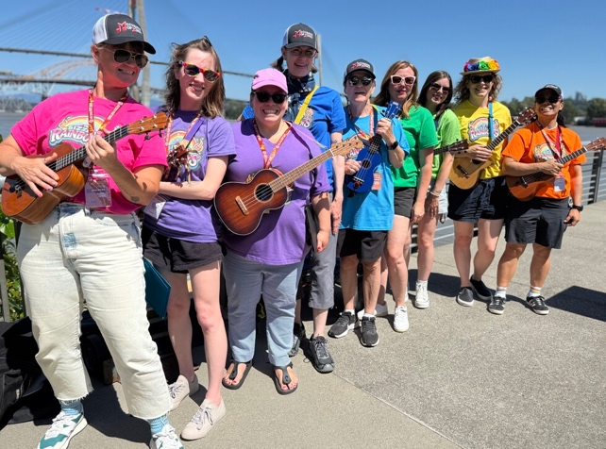

DETAILS
Date:
Monday, December 1, 2025
Time:
5:30 pm
8:00 pm
Organizer:
Mechanics of Music & City of New Westminster
Cost:
FREE
Website:
https://anvilcentre.com/our-events/downtowns-living-room-december-1/
Glow in the Park
December 1, 2025
January 4, 2026
Tipperary Park
Glow in the Park is a new holiday light display in Tipperary Park. Bundle up and explore glowing pathways with friends and family, and snap some Instagram-worthy photos to celebrate the season.
The display will be up Dec. 1 - Jan. 4.
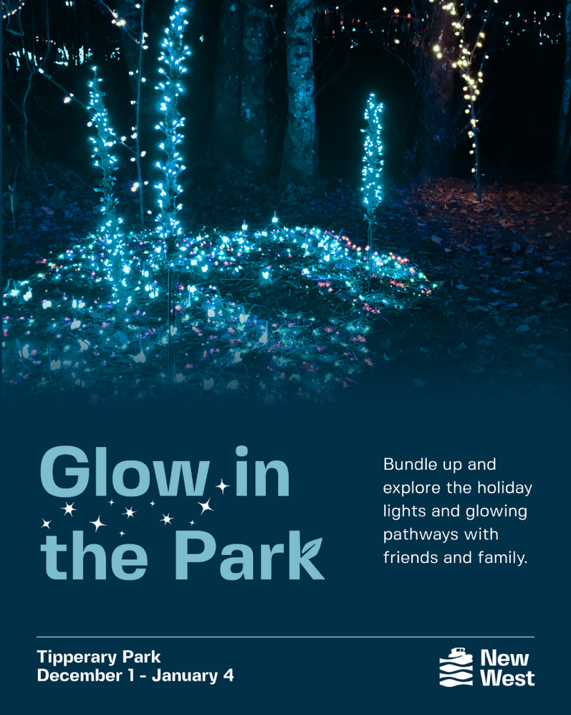

DETAILS
Date:
Monday, December 1, 2025
Sunday, January 4, 2026
Organizer:
City of New Westminster
Cost:
Free

LOCATION
Tipperary Park
Hyack Festival's Santa Claus Holiday Meet & Greet!
December 10, 2025
December 10, 2025
5:00 pm
7:00 pm
204 6th Street, New Westminster
Get ready for some festive cheer! The Hyack Festival Association invites you to a special Meet & Greet with Santa Claus! Bring your family and friends to enjoy holiday music and delicious treats.


DETAILS
Date:
Wednesday, December 10, 2025
Wednesday, December 10, 2025
Time:
5:00 pm
7:00 pm
Organizer:
Hyack Festival Association
Cost:
By Donation

LOCATION
204 6th Street, New Westminster

Christmas Market
December 12, 2025
December 12, 2025
5:00 pm
8:00 pm
320 Eighth St
Join us for our annual Christmas Market! This free, festive, family-friendly indoor event will feature:

Local vendors
Hot chocolate
Fun activities for kids
And more!

Come celebrate the season with us in the heart of New West!

Friday, December 12th
5-8pm
Freedom Church, 320 8th St, New Westminster, BC

We’re also looking for vendors and volunteers to be a part of making this event a success. If you’re interested, please sign up using the link below:

https://www.freedomchurchbc.com/upcoming-events


DETAILS
Date:
Friday, December 12, 2025
Friday, December 12, 2025
Time:5:00 pm-8:00 pm
Organizer:
Freedom Church
Cost:
Free
Website:
Volunteer & Vendor Signup!

Christmas Market
December 20, 2025
December 20, 2025
1:00 pm
5:00 pm
501 4th Avenue, New Westminster, BC
Our Christmas Market features beautiful crafts, delicious baked goods, and festive surprises — all lovingly created by our community. Enjoy the magic of the season!

DETAILS
Date:
Saturday, December 20, 2025
Saturday, December 20, 2025
Time:
1:00 pm
5:00 pm
Organizer:
Holy Eucharist Ukrainian Catholic Cathedral
Cost:
Free entrance

LOCATION
501 4th Avenue, New Westminster, BC

