August 2026 A&N Academic Montessori School Ltd.
SUN | MONDAY | TUESDAY | WEDNESDAY | THURSDAY | FRIDAY | SAT
 |  |  |  |  |  | 1
2 | 3  Centre closed  BC Day | 4 | 5 | 6 | 7  Show and Tell | 8
9 | 10 | 11 | 12 | 13 | 14  Show and Tell | 15
16 | 17 | 18 | 19 | 20 | 21  Show and Tell | 22
23 | 24  Last Day  Summer Closure | 25  Closed | 26  Closed | 27  Closed | 28  Closed | 29
30 | 31  Closed

No Daycare- Centre Closed August 3, 2026
Summer Break- Centre Closed August 25-August 31, 2026

Community Events
Uptown Live Summer Series
August 1, 2026
August 1, 2026
12:00 pm
4:00 pm
Various locations in Uptown New West
Free Live Music in Uptown New Westminster
The Uptown Live Summer Series, presented by TD Bank Group, transforms Uptown New Westminster into a vibrant outdoor stage every weekend this summer. Enjoy live, busker-style performances by talented local artists in plazas, patios, and street corners throughout Uptown. Check the website for the daily schedule and venue locations.
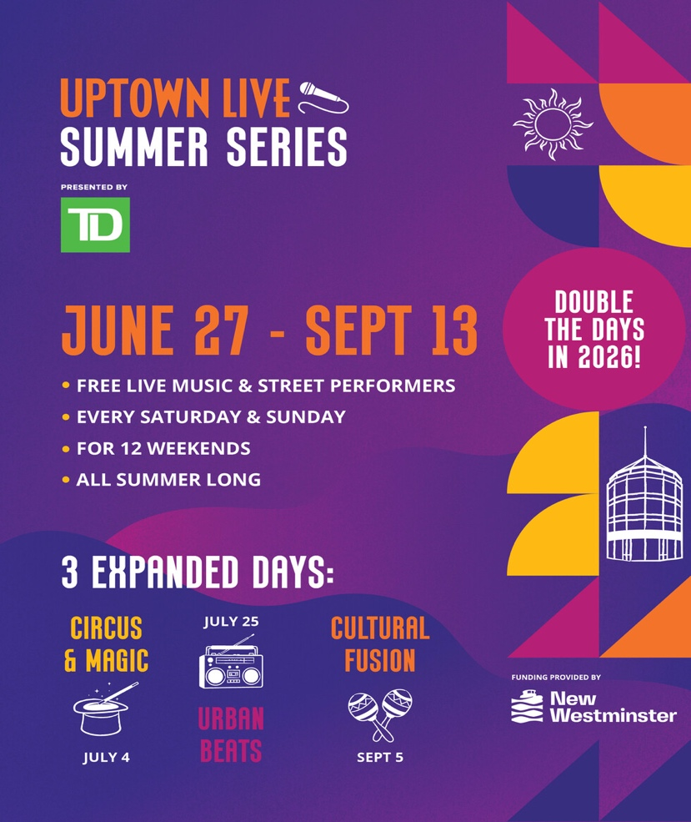

Downtown's Front Yard: Hyack Market Days
August 1, 2026
12:00 pm
6:00 pm
Hyack Square
Spend your Saturday in the heart of Downtown New West at Hyack Market Days in Hyack Square. Discover local makers, artisans, and small businesses, enjoy live music, and explore a rotating collection of unique finds, handcrafted goods, and delicious treats. Every market offers something new to uncover.
Presented by the Downtown BIA and City of New Westminster.
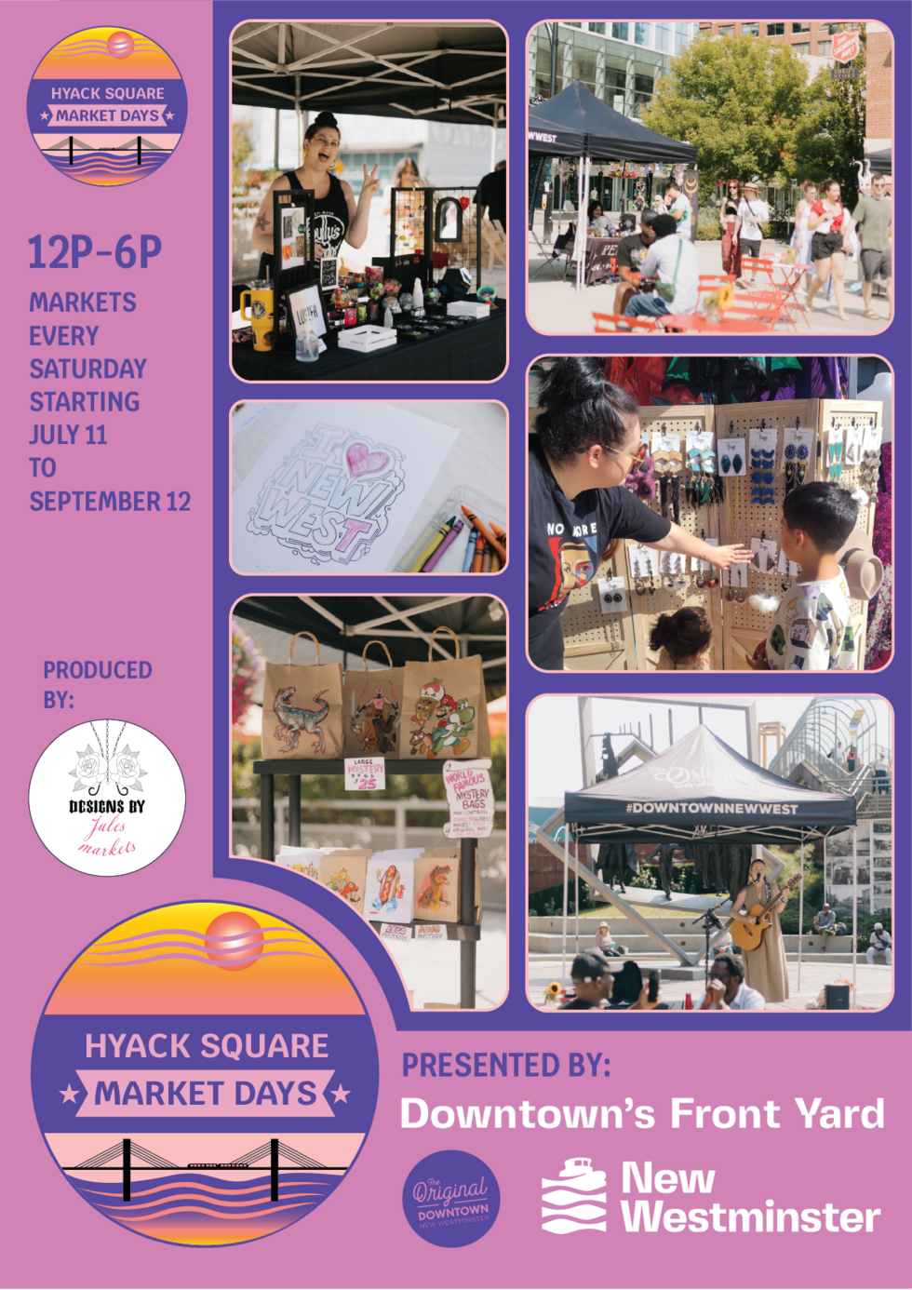
Multi-family Inclusive Garage Sale
August 1, 2026
August 1, 2026
10:00 am
2:00 pm
43 Hastings Street, New Westminster
Join us for a truly special community event! Six families from our unique Community Living building—a joint initiative by CLS and the City of New Westminster—are coming together for our very first collaborative garage sale. Our building is a proud, inclusive space where individuals with disabilities and diverse neighbors live, support one another, and thrive together as one community.

We will have a wide variety of items available, including beautiful handmade crafts created by our talented residents, kitchenware, household goods, children's toys, clothes, and shoes.

You don’t need to buy anything to make a difference—just coming by to chat, connect, and show your support means the world to us. We look forward to welcoming our New West neighbors!
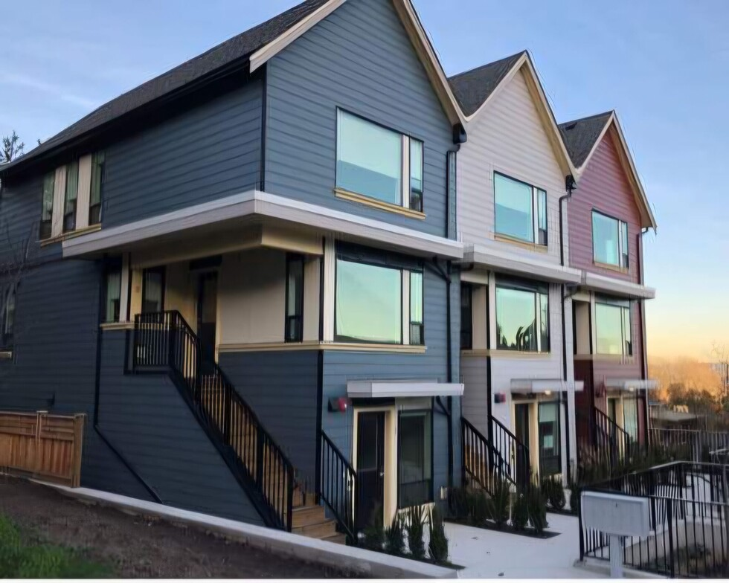

Movies in the Park: Back to the Future
August 5, 2026
8:00 pm
11:00 pm
Westminster Pier Park festival lawn
Join us for Movies in the Park!
Each Wednesday in August, plus a bonus back-to-school edition on September 4, join the City of New Westminster as we host an outdoor movie in a local park. Featuring complimentary programming as you settle in such as music or activities, these movies take place after sunset. Bring your own blankets, chairs, and snacks, and get comfy.
These events will be cancelled if there is rain in the forecast, so watch the City's social media channels and this event listing for an update.
August 5, join us at 8pm at Westminster Pier Park on the Festival Lawn for the 1985 classic, Back to the Future*.
Sunset is at 8:45pm so expect the movie to start around 9.
*This movie is rated PG, and runs 116 minutes, meaning the screening is likely to end around 10:40pm. Only you know if this movie is right for you and your family, so if you are unfamiliar with this film, check a parents' guide here.

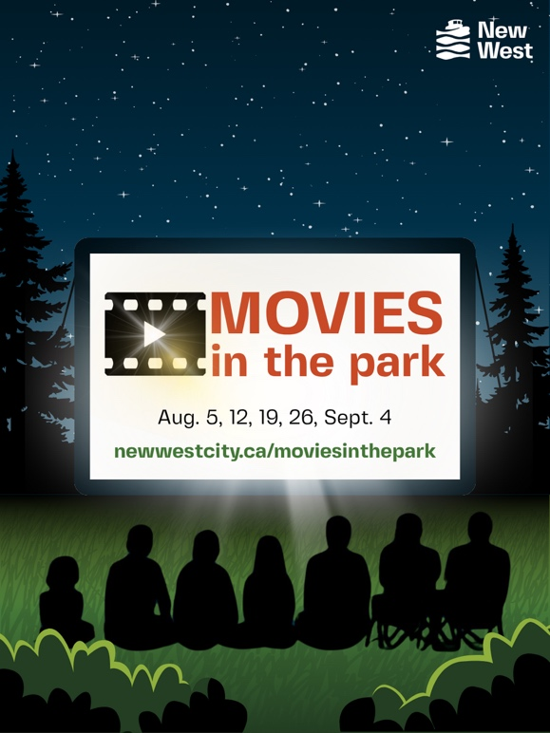

Movies in the Park: Lilo and Stitch (2025)
August 19, 2026
7:00 pm
11:00 pm
Queensborough Community Centre (outside)
Join us for Movies in the Park!
Each Wednesday in August, plus a bonus back-to-school edition on September 4, join the City of New Westminster as we host an outdoor movie in a local park. Featuring complimentary programming as you settle in such as music or activities, these movies take place after sunset. Bring your own blankets, chairs, and snacks, and get comfy.
These events will be cancelled if there is rain in the forecast, so watch the City's social media channels and this event listing for an update.
August 19, join us at 8pm at Queensborough Community Centre at the outdoor stage for the 2025 reboot of Lilo and Stitch*.
Sunset is at 8:20pm so expect the movie to start just before 9.
*This movie is rated PG, and runs 108 minutes, meaning the screening is likely to end around 10:15pm. Only you know if this movie is right for you and your family, so if you are unfamiliar with this film, check a parents' guide here.
Preshow Program
7:00 PM - 9:00 PM.....Family Friendly Lawn Games
7:30 PM - 8:00 PM.... Hawaiian Hula Dance Class
8:10 PM - 8:55 PM.....Live Music with Nate Batara
Food Vendors:
- Alohaaa - Hawaiian Inspired Hot Dogs
- Gong cha Bubble Tea


Summer Music & Fireworks Festival
August 22, 2026
August 22, 2026
4:00 pm
10:00 pm
810 Quayside Drive
Join us at the New Westminster Quay for a fantastic festival with artisan market vendors and exhibitors, live entertainment, delicious food, and a Fireworks extraordinaire! Walk down the boardwalk and discover free activities in the new parks, and stick around to enjoy the live entertainment and fireworks show. The boardwalk fills up fast, make sure you show up early to snag a prime viewing location! Find more details on Facebook and Instagram @Hyackfestivalassociation



Recycling Pop-Up
August 29, 2026
10:00 am
2:00 pm
Engineering Operations yard at 901 First Street
Recycle beyond the bin! Not everything is accepted in your residential recycling bins. Drop off your depot-only recyclables at our recycling pop-up event and make a positive impact on our community and environment! Our knowledgeable Solid Waste and Recycling Team members will be on site to answer questions and help guide you on how to recycle right in order to minimize recycling contamination.

Accepted materials:

Soft and hardcover books
Soft, flexible plastics
Styrofoam (food tray type)
Textiles and clothing
Small household appliances (ex. Toasters, coffee makers, etc.)
Small scrap metals (ex. Pots and pans, broken hammers, etc.)

We will NOT be accepting large appliances, large scrap metals, large electronics, glass, garbage, hazardous materials, batteries, or other recyclables not mentioned above. Please download the Recycle Coach app for more information on where you can take these items.

