October 2025 A&N Academic Montessori School Ltd.
SUN | MONDAY | TUESDAY | WEDNESDAY | THURSDAY | FRIDAY | SAT
 |  |  | 1 | 2 | 3  Show and Tell | 4
5 | 6 | 7 | 8 | 9 | 10  Show and Tell | 11
12 | 13  Thanksgiving  CENTRE CLOSED | 14 | 15 | 16  Last day before Chocolate Bar Fundraiser Ends | 17  Show and Tell | 18
19 | 20 | 21 | 22 | 23 | 24  Pumpkin Patch  Field Trip  12:00-2:00 | 25
26 | 27 | 28 | 29 | 30  Last  Farmers Market  3:00-7:00 | 31  Sapperton Trick or Treat Event  11:30-1:30

Dear Parents, Guardians and Children:

We have had a wonderful September, and the children came back from the summer holiday ready to learn, play and grow! A friendly reminder that the warm weather is coming to an end and as fall is here, we remind parents to please send your child with warmer clothes, coats, hats, mittens. If you need assistance in finding weather appropriate gear or have any extras that your child out grew, we are here to help, please reach out!

October 13, 2025, No Daycare- Centre Closed- Thanksgiving

October 17, 2025- Funds Raised Due for Purdy’s Chocolate Bar Fundraiser
This year for our fundraiser we will be selling chocolate bars at a cost of $4.00 a bar, there are milk chocolate and dark chocolate bars and in one week we will receive the almond bars at a cost $8.00 a bar. We are asking parents to reach out to their community, family and friends to help support our efforts with the fundraiser. If each child sells at least a box at $80, we receive $37.00 dollars from that box to add equipment to our playground. Please be advised that if you would prefer to just donate the funds instead of fundraising that is fine. All Funds raised will be used to help improve the children’s play space outside. All funds collected are due by October 17, 2025, thank you for your continued support!

October 24- @ 12:00pm- 2:00pm Laity Farms Pumpkin Patch Field Trip- Field trip forms with more information will be handed out after Thanksgiving! If you cannot join us the daycare will remain open. If you would like to use the daycare before and after the event that is also an option as daycare will remain open.

October 31, @ 11:30am Meet at Sapperton Park. Sapperton Trick or Treat- The teachers will start a list of children who will be joining us for the event! This is a parent participation event we ask that children have an adult trick or treating with them. If you cannot join us the daycare will remain open. If you would like to use the daycare before and after the event that is also an option as daycare will remain open. No permission slips necessary just confirmation by October 17, 2025, Please!

Show and Tell-Each week your child can bring in an item to talk and share with the class, please try not to bring toys instead bring seasonal items.

COMMUNITY EVENTS

New West Farmers Market
3:00 pm-7:00 pm Thursday
Tipperary Park - 315 Queens Ave-FREE EVENT
It's never been more important to shop local, and the New West Farmers Market has you covered! Everything sold at the New West Farmers Market is either made, foraged, or grown right here in British Columbia, so take the guess work out of your weekly shop, bring your friends and support the New West economy every Thursday from March 27th - October 30th in Tipperary Park! Shopping for deals? Sign up for a $10 Annual Membership and gain access to exclusive vendor discounts on the first market of every month! Featuring 45+ vendors, including farm-fresh produce, plants, quality crafts from local artists and artisans, gourmet prepared foods, food trucks, community information, live entertainment, and more!

Creativity Workshop - Hand Stitching
October 2, 2025
7:00 pm
9:00 pm
təməsew̓txʷ Aquatic and Community Centre, 65 E Sixth Ave
Be inspired by local artists with a social art workshop, featuring a new project or theme each week. Take creative risks, use your imagination, and have fun as you practice your skills or learn something new. Join artist Sarah Elizabeth Miller and discover the joy of hand stitching in this beginner-friendly sewing and embroidery class! You'll create a simple felted shape and learn a few basic embroidery stitches to personalize your project. It's a great way to explore your creativity, pick up new skills, and enjoy some mindful making. All materials provided—no experience needed! Presented in partnership with Arts New West.
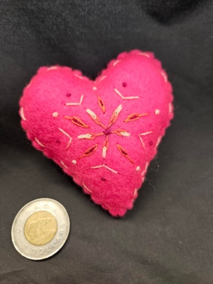

DETAILS
Date:
Thursday, October 2, 2025
Time:
7:00 pm-9:00 pm
Organizer:
City of New Westminster
Cost:
Free
Website:
https://cityofnewwestminster.perfectmind.com/23693/Clients/BookMe4LandingPages/CoursesLandingPage?widgetId=50a33660-b4f7-44d9-9256-e10effec8641&redirectedFromEmbededMode=False&courseId=8443ec30-7a9c-4932-85ba-925e9163dde4

Uptown Plaza Opening with Ribbon Cutting and Reception
October 3, 2025
4:00 pm
9:00 pm
Uptown Plaza - 6th Street and Belmont Street
You are invited to the opening of our latest refreshed and rejuvenated arts and cultural space, Uptown Plaza. Join us for a brief reception as we warm this new community space in Uptown on Friday October 3rd from 4pm to 9pm with an official opening at 6pm. Remarks not required. Uptown Plaza is located at 6th Street and Belmont Street. Easiest parking on Belmont of 7th Street.
- Buskers and activities– 4:00 pm - 6:00 pm
- Remarks and ribbon cutting – 6:00 pm
- DJ dance party – 6:15 pm to 9:00 pm
Beverages available to purchase.
Programming provided in partnership with the Uptown Business Association.
All are welcome to attend.
In the event of rain, this event will be shortened to 5:00 pm to 7:00 pm. More details will be added as they are confirmed.

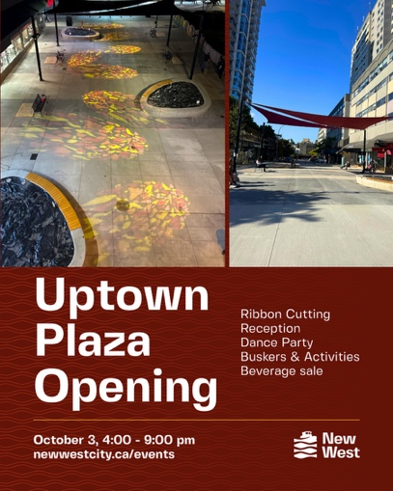

DETAILS
Date:
Friday, October 3, 2025
Time:
4:00 pm
9:00 pm
Organizer:
City of New Westminster
Cost:
free

LOCATION
Uptown Plaza - 6th Street and Belmont Street

Fire Department Open House
October 4, 2025
10:00 am
2:00 pm
1 East 6th Ave
New Westminster Fire and Rescue Services is dedicated to reducing the occurrence of home fires through prevention, safety education and community outreach. As part of this effort, we are having our Annual Open House on Saturday, October 4th, 2025 from 10:00 am to 2:00 pm at Glenbrook Fire Hall (McBride & East 6th Ave).
This year’s theme is “Charge into Fire Safety: Lithium-Ion Batteries in Your Home” which serves to remind us of the importance of using, charging and recycling lithium-ion batteries safely to reduce the risk of fires in homes and communities.
This event allows the public to not only see behind the scenes at a Fire Hall but gives them an opportunity to network with the various emergency and community services which are available in New Westminster. The event takes place rain or shine with visitors enjoying this annual informative, educational and interactive event.
The New Westminster Firefighter Charitable will also have their annual BBQ (by donation) at the event. Fire Prevention Week is observed each year during the October in commemoration of the Great Chicago Fire, which began on October 8th, 1871 and caused devastating damage.
We look forward to seeing you at the Fire Hall!
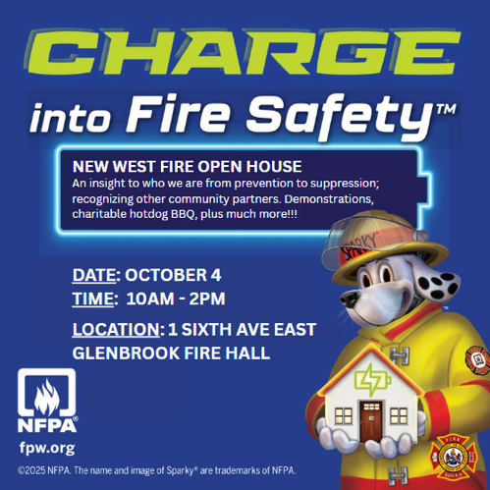

DETAILS
Date:
Saturday, October 4, 2025
Time:
10:00 am
2:00 pm
Organizer:
New Westminster Fire & Rescue Services
Cost:
FREE
Website:
NWFRS Website

LOCATION
1 East 6th Ave

New West Cultural Crawl
October 4, 2025
October 5, 2025
11:00 am
5:00 pm
777 Columbia Street
The 22nd Annual New West Cultural Crawl | October 4–5, 2025 Discover the vibrant arts community of New Westminster during this free, family-friendly weekend celebration. With over 150 artists across 30+ venues, the Crawl invites you to explore galleries, studios, and cultural spaces throughout the city. Highlights include hands-on workshops, family activities, Indigenous and multicultural exhibitions, guided bicycle tours of Crawl venues, and a Downtown Public Art Tour. Special events include Ode to the Pattullo Bridge at the Anvil Centre and an Artist-in-Residence showcase at the New Media Gallery. From painting and photography to performance and interactive experiences, the Crawl is your chance to connect with artists, discover new perspectives, and celebrate the role of art in building community. For full event details, visit: www.newwestculturalcrawl.com


DETAILS
Date:
Saturday, October 4, 2025
Sunday, October 5, 2025
Time:
11:00 am
5:00 pm
Organizer:
Arts New West
Cost:
free
Website:
www.newwestculturalcrawl.com

LOCATION
777 Columbia Street

Concerts In The Square
October 5, 2025
October 26, 2025
1:00 pm
3:00 pm
796 Columbia St, New Westminster, BC
Stop by Hyack Square to enjoy performances from local artists for the Month of October!

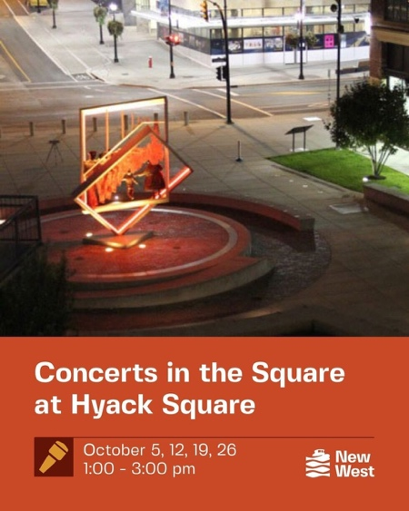
DETAILS
Date:
Sunday, October 5, 2025
Sunday, October 26, 2025
Time:
1:00 pm
3:00 pm

Creativity Workshop – Watercolour Line and Wash
October 9, 2025
7:00 pm
9:00 pm
Queensborough Community Centre, 920 Ewen Avenue
Wash (19+ years)
Be inspired by local artists with a social art workshop, featuring a new project or theme each week. Take creative risks, use your imagination, and have fun as you practice your skills or learn something new. All supplies will be provided. No registration. Join artist Julie Epp for a playful exploration of watercolour line and wash! In this workshop, you’ll learn how to sketch a whimsical house and bring it to life with ink outlines and loose, vibrant washes of colour. We’ll cover simple drawing techniques, tips for combining pen and watercolour, and ways to keep your artwork light, expressive, and full of charm, perfect for beginners and experienced artists alike. Presented in partnership with Arts New West.

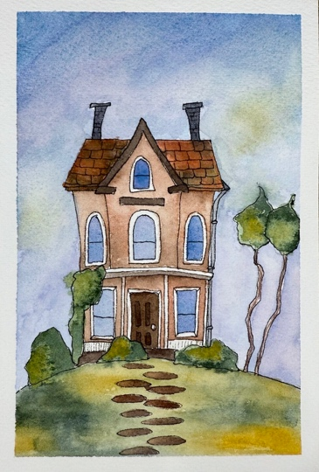
DETAILS
Date:
Thursday, October 9, 2025
Time:
7:00 pm
9:00 pm
Organizer:
City of New Westminster
Cost:
Free
Website:
https://cityofnewwestminster.perfectmind.com/23693/Clients/BookMe4LandingPages/CoursesLandingPage?widgetId=50a33660-b4f7-44d9-9256-e10effec8641&redirectedFromEmbededMode=False&courseId=2a241c27-e20a-4201-a2cc-3bac511b32b6

LOCATION
Queensborough Community Centre, 920 Ewen Avenue

Health Fair
October 18, 2025
October 18, 2025
10:00 am
4:00 pm
330 Royal Avenue, New Westminster
Excitement is in the air! Get ready to be part of something extraordinary at St. Peter's Parish this fall.
It's an event like no other, and we want you to be there!
Body, Mind & Spirit - Together in Wellness at St. Peter's
Join us for a day dedicated to health, connection, and community. St. Peter's Health Fair brings together local health professionals, wellness resources, and faith-based support to help you care for your whole self - body, mind, and spirit.
Screenings, activities, and guidance for all ages.
Everyone is welcome!
When? October 18, 10 am - 4 pm


DETAILS
Date:
Saturday, October 18, 2025
Saturday, October 18, 2025
Time:
10:00 am
4:00 pm

Moonlight Movies: Halloween Edition
October 25, 2025
5:00 pm
8:00 pm
Queensborough Community Centre
Get ready for a spook-tacular night at Moonlight Movies – Halloween Edition, a free indoor movie night on a large projection, perfect for the whole family! Dress up in your best Halloween costume, bring your blankets and spooky spirit, and settle in for a fun-filled evening.
Enjoy a family-friendly Halloween movie on the big screen, with prizes awarded for best costumes—so don’t hold back on the creativity and see you all there!
Registration required
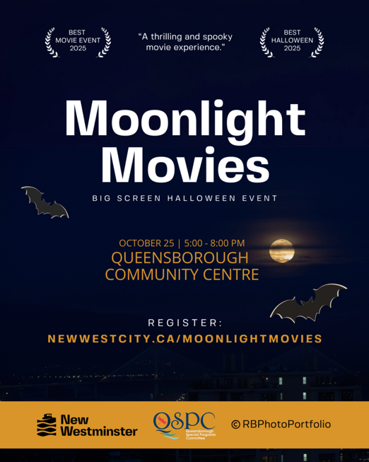

DETAILS
Date:
Saturday, October 25, 2025
Time:
5:00 pm
8:00 pm
Organizer:
Queensborough Special Programs Committee in partnership with the City of New Westminster
Cost:
Free
Website:
Register online

LOCATION
Queensborough Community Centre

The Talking Circle
October 30, 2025
1:00 pm
3:00 pm
The Talking Circle is an initiative under the Crises Response Pilot Project. Led by CRT Outreach, the goal is to create connections in the community.
Talking Circle events are for those who are housing insecure, and who self-identify as Indigenous. Participants can drop-in to visit with an Indigenous elder at these afternoon sessions. There are five sessions in total for 2025:
Thursday July 31
Thursday August 28
Thursday September 25
Thursday October 30
Thursday November 27
For more information, please email outreach@newwestcity.ca
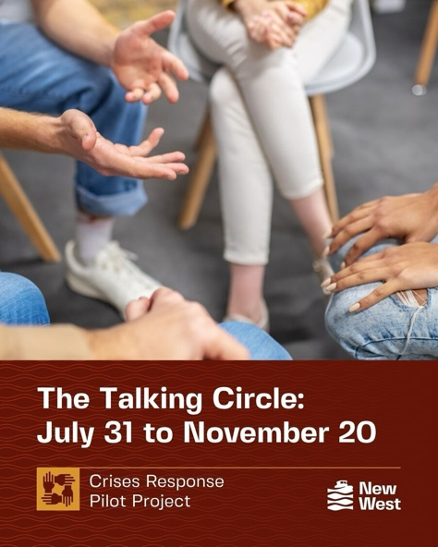

DETAILS
Date:
Thursday, October 30, 2025
Time:
1:00 pm
3:00 pm
Organizer:
City of New Westminster's Crises Response Outreach Team
Cost:
FREE
Website:
Learn more about the Crises Response Pilot Project

