November 2025 A&N Academic Montessori School Ltd.
SUN | MONDAY | TUESDAY | WEDNESDAY | THURSDAY | FRIDAY | SAT
 |  |  |  |  |  | 1
2 | 3 | 4 | 5 | 6 | 7  Show and Tell | 8
9 | 10 | 11  Remembrance Day  CENTRE CLOSED | 12 | 13 | 14  Show and Tell | 15
16 | 17 | 18 | 19 | 20 | 21  Show and Tell | 22
23 | 24 | 25 | 26 | 27 | 28  Show and Tell | 29
30

Dear Parents, Guardians and Children:

We had a great Pumpkin Patch Field Trip, thank you for everyone’s help and support to make this day successful. With out it, theses field trips would not be possible.

November 11, 2025, No Daycare- Centre Closed- Remembrance Day

Funds Raised Due for Purdy’s Chocolate Bar Fundraiser have been very successful. We still have chocolate bars that need to be sold, if parents are interested, please reach out to teachers. As soon as they are all sold, we will be able to start working on the playground space.

Show and Tell-Each week your child can bring in an item to talk and share with the class, please try not to bring toys instead bring seasonal items.

COMMUNITY EVENTS

World Series: Game 7
November 1, 2025
5:00 pm
Queen's Park Arena, Moody Park Arena & Anvil Centre
If we go to game 7, catch the final matchup at these locations.
Locations:
- Anvil Centre – Two large-screen TVs set up with tables and chairs in the foyer on Level 4. Outside food welcome; no concession.
- Queen’s Park Arena – Lobby viewing with limited seating. Concession open.
- Moody Park Arena – Overhead screen viewing during skating programs; limited seating. Concession open.

Joy at the End of the World: A Writing Workshop
November 2, 2025
November 2, 2025
3:30 pm
4:30 pm
New Westminster Public Library, 716 6th Avenue, New Westminster
The climate crisis is becoming more urgent every year, but it’s so big and scary that we often struggle with where to start. In this hands-on writing session, we’ll make space for our feelings and work toward achievable individual and collective ideas for healing ourselves and our planet. With a mix of small group discussion, journaling, meditation, and resources from the Climate Wayfinding program, come discover that joy is possible as we engage our imaginations to create a better, fairer, sustainable world for everyone to live in. The program is led by local author, Julianne Harvey. This event is part of Climate Action Week at the New Westminster Public Library, many events from November 1-7, 2025.
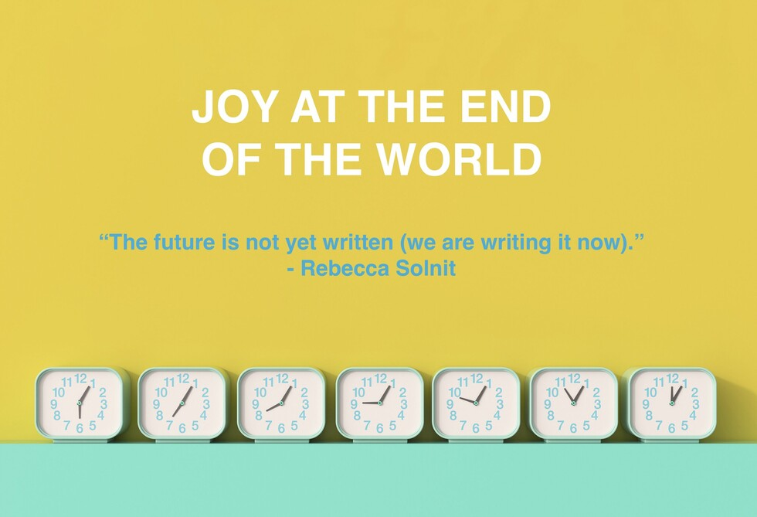

Details
Date:
Sunday, November 2, 2025
Sunday, November 2, 2025
Time:
3:30 pm
4:30 pm
Organizer:
New Westminster Public Library
Cost:
free
Website:
Register

Pumpkin Smash
November 2, 2025
9:00 am
1:00 pm
1 East 6th Avenue (Fire Hall #1)
Bring your pumpkins to the Fire Hall and for a donation watch New Westminster Firefighters Charitable Society in action! We'll hoist them up Tower 1 and let gravity do the rest. Its a smashing good time for the whole family at our 2nd Annual Pumpkin Smash!
Contactless donation by card available.
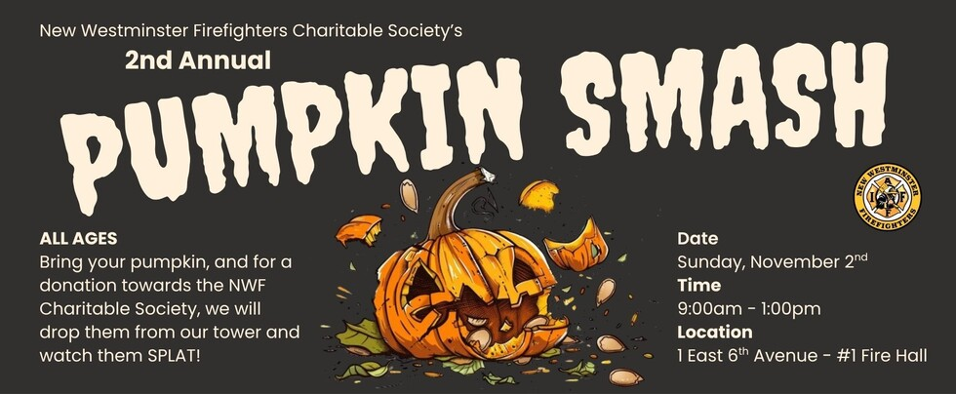

Details
Date:
Sunday, November 2, 2025
Time:
9:00 am
1:00 pm
Organizer:
New Westminster Firefighters Charitable Society
Cost:
FREE
Website:
More Information!

Location
1 East 6th Avenue (Fire Hall #1)

Downtown's Living Room
November 3, 2025
5:30 pm
8:00 pm
What's happening during the next edition of Downtown's Living Room? Come to Anvil Centre on Monday, November 3 for a sewable tech session!
Liven up your fashion with lights: in this hands-on workshop, participants will let their creativity flow by learning how to design and program tiny, wearable lights. Using beginner-friendly electronics and conductive thread, you'll explore the basics of coding and circuitry while creating your own illuminated fabric project.
Downtown's Living Room takes place every Monday night at 5:30 PM. This is your chance to come hang out, relax, make new friends and enjoy different activities on offer...everyone is welcome!
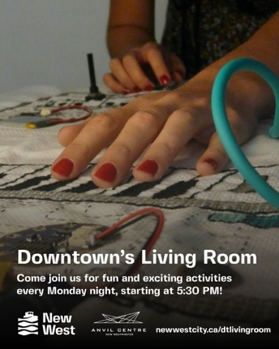

Details
Date:
Monday, November 3, 2025
Time:
5:30 pm
8:00 pm
Organizer:
City of New Westminster
Cost:
FREE
Website:
Learn more about Downtown's Living Room!

Remembrance Day Ceremony
November 11, 2025
10:25 am
12:30 pm
City Hall Cenotaph, 511 Royal Avenue
On Remembrance Day we honour those who gave their lives to serve our country.
Find more ways to remember (and information on how to order poppy wreaths).
The honour roll below is presented in remembrance of our fallen heroes.
Honour Roll

Ways to Watch the Ceremony
Attend in person at the City Hall Cenotaph (511 Royal Avenue) starting at 10:25am. Watch the livestream coverage starting at 10:25 am on YouTube. A sign language interpreter will also be present at the service.
YouTube

Event Schedule
- 09:00 am - Wreath pick up, City Hall front lawn
- 10:15 am - Parade assembly at Queen’s Ave. and Sixth St.
- 10:25 am - Outdoor service at the City Hall Cenotaph

Q to Q Ferry
Please note the Q to Q Ferry service will start at 9:00 am on Remembrance Day for those who wish to travel to City Hall via ferry.

Road Closures
The following road closures will be in effect on Tuesday, November 11, from 6:00am to 1:00pm:
- Royal Avenue (Eighth Street to Third Street)
- Sixth Street (Third Avenue to Cunningham Street)
- Queens Avenue (Seventh Street to Fourth Street)
Additional parking restrictions will be in effect from 5:00am to 1:00pm. An accessible parking and pickup/drop-off area will be available on Seventh Street.
Royal Avenue traffic going to the Pattullo Bridge will be detoured to Eighth Street and Sixth Avenue. Trucks to Surrey are advised to use the Port Mann Bridge. Find a map here.

Community Partners
Remembrance Day is offered in partnership with the New Westminster Royal Canadian Legion and the Royal Westminster Regiment.
This event is also made possible thanks to the support of Royal Canadian Legion New Westminster Branch No. 2 volunteers, Last Door Recovery Centre, and Job's Daughter.
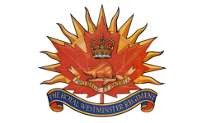
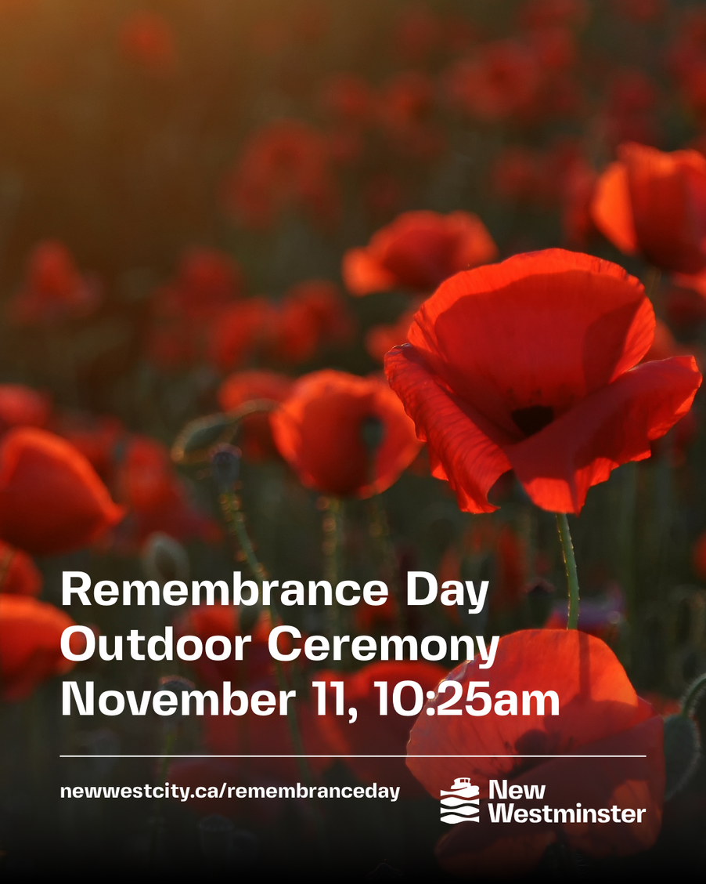

Details
Date:
Tuesday, November 11, 2025
Time:
10:25 am
12:30 pm
Organizer:
City of New Westminster
Cost:
Free
Website:
Find more ways to remember

DougZine Fest
November 12, 2025
12:00 pm
4:00 pm
700 Royal Ave
Douglas College (New Westminster campus) is hosting its second annual Zine Festival with over 20 vendors and a collage creation station on November 12 noon - 4. On the concourse (main floor)
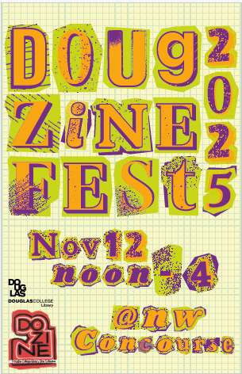

Details
Date:
Wednesday, November 12, 2025
Time:
12:00 pm
4:00 pm
Organizer:
Katharine Shipley
Cost:
Free
Website:
For more information on Zines

Location
700 Royal Ave

Christmas Craft Sale and Raffle
November 15, 2025
11:00 am
4:00 pm
649 8th Avenue
Thornbridge Gardens Crafters annual sale Saturday, November 15, 2025, 11 a.m. to 4 p.m. Underground parking available, 649 8th Avenue. Money raised from the sale and raffle goes to the Lower Mainland Food Bank. Unsold knitted items to New Westminster street youth. Other unsold items to the Royal Columbian Hospital Thrift Shop.

Details
Date:
Saturday, November 15, 2025
Time:
11:00 am
4:00 pm
Organizer:
Thornbridge Crafters
Cost:
No admission fee

Herbert Spencer Christmas Craft Fair
November 22, 2025
10:00 am
3:00 pm
605 Second Street, New Westminster, British Columbia, Canada V3L 5R9
This popular community event & fundraiser for our school will be showcasing 60+ amazing professional artisans & vendors, a sweet bake sale with Mrs. Claus, bistro with tasty food and drinks, & Candy Cane Lane: featuring unique goods made by our very own Herbert Spencer student crafters!

Mark your calendars & come shop with us on November 22rd, 10am-3pm. The Herbert Spencer Christmas Craft Fair is a fun holiday event not to be missed & admission is FREE!
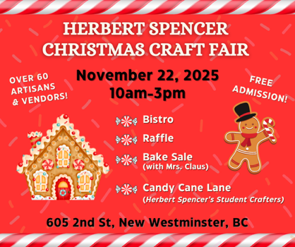

Details
Date:
Saturday, November 22, 2025
Time:
10:00 am
3:00 pm
Organizer:
École Herbert Spencer Elementary School PAC
Cost:
Admission is FREE!
Website:
Follow us on Facebook & Instagram: Herbert Spencer Christmas Craft Fair

The Talking Circle
November 27, 2025
1:00 pm
3:00 pm
The Talking Circle is an initiative under the Crises Response Pilot Project. Led by CRT Outreach, the goal is to create connections in the community.
Talking Circle events are for those who are housing insecure, and who self-identify as Indigenous. Participants can drop-in to visit with an Indigenous elder at these afternoon sessions. There are five sessions in total for 2025:
Thursday July 31
Thursday August 28
Thursday September 25
Thursday October 30
Thursday November 27
For more information, please email outreach@newwestcity.ca
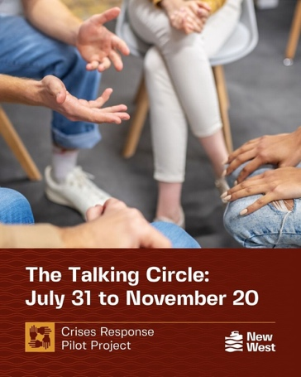

Details
Date:
Thursday, November 27, 2025
Time:
1:00 pm
3:00 pm
Organizer:
City of New Westminster's Crises Response Outreach Team
Cost:
FREE
Website:
Learn more about the Crises Response Pilot Project

